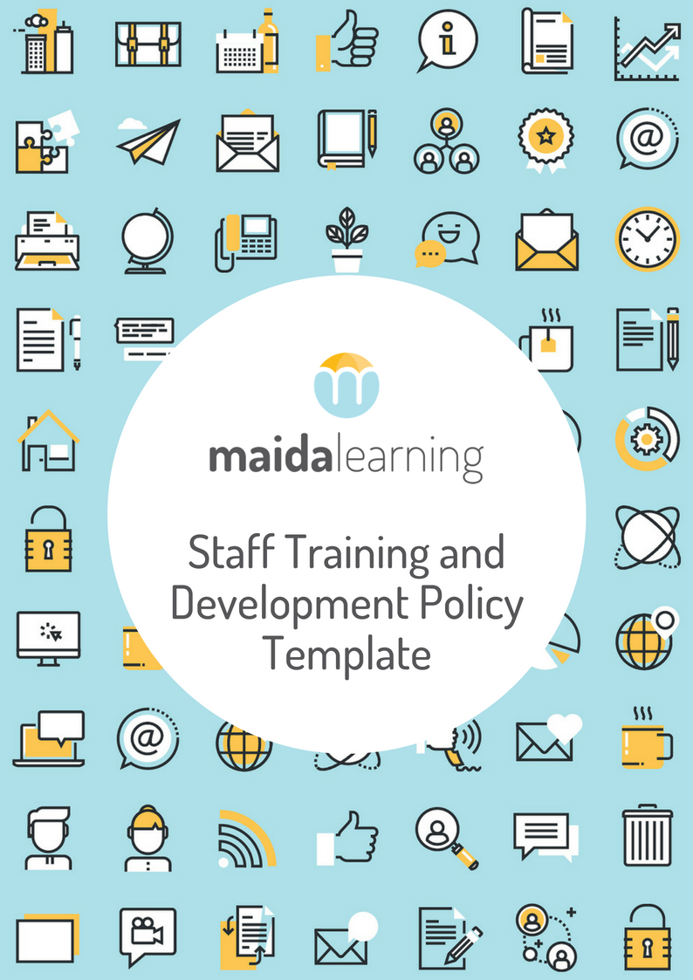



We have created this template and made it available to help you develop your ideas, manage and grow your practice. Whilst we endeavour to help all allied health practices, we acknowledge that practices are all different and therefore are unable to provide a universal resource that suits everyone. It is expected that you customise this template to suit the individual needs of your practice. We encourage you to seek financial, legal or specialist advice as applicable to your individual circumstances.

How to use this template:

1. Add your logo to the top of the next page (to the start of your template) so it is branded to your practice
2. Rename the policy if you wish – you are free to make it your own, so choose a title that suits your practice
3. Add your practice details to the ‘red’ sections
4. Ensure you read the policy so you know what it says! If there are any parts that don’t apply to you or you want to reword, be sure to edit these and make changes.
5. Add your new policy to your policy and procedures list so you don’t forget you have it!
6. Find a place to store it so it is easy to find.
7. Work out how you are going to inform people about the new policy if needed.
8. Feel free to delete these first two instructional pages.

(add your practice logo here)

Staff Training and Development Policy

1. Purpose
   1. [LongEmployerName] (‘[ShortEmployerName]’) recognises the importance of training and developing its staff.
   2. [ShortEmployerName] understands that its employees are key to its success as an organisation. It, therefore, encourages its staff to be continually improving their skills and abilities both through on-the-job and off-the-job training.
   3. [ShortEmployerName] acknowledges that training and development of staff provides benefits both to its employees in terms of their overall career and prospects for advancement within the organisation, as well as being central to the success it is able to achieve as a business.
   4. This Staff Training and Development Policy (**Policy**) sets out what [ShortEmployerName] may offer employees through training and development opportunities aimed at promoting the growth of individuals, teams and achieving success for the organisation.
2. Commencement of Policy
   1. This Policy will commence on [CommencementDate]. It replaces all other policies dealing with staff training and development (whether written or not).
3. Application of the Policy
   1. This Policy applies to all employees of [ShortEmployerName]. This Policy does not form part of any employee’s contract of employment.
4. Training
   1. [ShortEmployerName] may require you to undertake specific training related to your current position, or as a prerequisite for performing a different position, for example, if you are promoted to a higher position. Any such training may be carried out either at [ShortEmployerName]’s premises or externally.
   2. Training opportunities may also arise as part of your performance review. [ShortEmployerName] encourages employees to propose suggestions for employment-related training to assist their development.
   3. You are required to have the permission of [ShortEmployerName] prior to either signing up or attending, a training course. If you fail to obtain permission, [ShortEmployerName] at its discretion, may decide not to reimburse you for any course fees you have paid or discipline you for any unauthorised time you have taken off work (up to and including termination of employment).
5. How does staff development work?
   1. Individual staff training and development needs should be discussed during [ShortEmployerName]’s staff development review process. The review process is designed to:
      1. encourage constructive dialogue between staff members and their supervisors;
      2. enhance the staff member's professional development;
      3. clarify job responsibilities and performance goals/expectations;
      4. establish appropriate development and performance objectives;
      5. help staff identify a possible career path for themselves;
      6. identify ways in which [ShortEmployerName]’s organisation and/or operation might enable individuals to improve their performance;
      7. ensure that information on job performance and achievements is recorded in each staff member's employment history; and
      8. provide a basis for decisions on remuneration.
6. What can [ShortEmployerName] offer?
   1. [ShortEmployerName] may offer any of the following opportunities for staff development:
      1. an induction program when you join [ShortEmployerName], to understand the manner in which [ShortEmployerName] operates, including what contribution you are expected to make;
      2. various degrees of support as you develop the competence and capability for which you have been employed;
      3. the opportunity to develop new competencies and capabilities relevant to your employment with [ShortEmployerName], and which enhance your career prospects and lifelong learning both within and outside [ShortEmployerName];
      4. to participate in [ShortEmployerName]’s staff development review process with your line manager, including identifying opportunities for ongoing training and/or support, an annual review of your previous development programs and identification of plans for the future; and
      5. an exit interview when you leave [ShortEmployerName], so that your comments may be incorporated into the development programs of other members of staff.
7. What [ShortEmployerName] Expects From You
   1. [ShortEmployerName] expects that you will:
8. develop your skills and capabilities which are aligned with [ShortEmployerName]’s strategy at the appropriate level, e.g. team or individual;
9. participate in staff development review process in partnership with your line manager, including an annual review of your past development and identification of future plans;
10. take personal responsibility to update your specific expertise on a regular basis, as appropriate to the nature of your job;
11. identify any training and development opportunities and raise these with management for their consideration;
12. contribute to team staff development where appropriate; and
13. keep a record of your staff development activity.

Variations

[your practice name] reserves the right to vary, replace or terminate this policy from time to time.

## Policy version and revision information

|  |  |
| --- | --- |
| Policy Authorised by: [Name] | Original issue: Date |
| Policy Maintained by: [Name] | Current version: 1 |
| Review date: [PolicyReviewDate] |  |

## Employee acknowledgement

I acknowledge:

* receiving the [ShortEmployerName] Policy;
* that I will comply with the Policy; and
* that there may be disciplinary consequences if I fail to comply with the Policy, which may result in the termination of my employment.

|  |  |
| --- | --- |
| Your name: |  |
| Signed: |  |
| Date: |  |